Character Design Document

project Leviathan

Rose-Hulman Institute of Technology

Zhaoyuan Sun 

Weimu Song

Yuqi Zhou

Song Luo

Zezhi Xia

Table of Contents

**1. Description** **3**

**2. Character References** **3**

2.1 Player 3

2.1.1 Race 3

2.1.2 Customization Options 7

2.2 Non-player Character 9

2.2.1 The Host of the Kingfest 9

2.2.2 Main Characters In the Colonist War: 10

**3. Player Details And Monsters’ Attack Styles** **13**

3.1 Player 13

3.2 Enemies 14

3.2.1 Boss 14

3.2.2 Monster 15

**4. Enemies AI** **16**

**5. Character Animation List** **17**

5.1 Basic Animation 17

5.2 Animation Integration Plan 21

**Image Reference** **22**

# 

# 

# 1. Description

The project Leviathan is an online competitive shooter game. Each player in this game has the chance to build his/her own hero and modify it. As the game development team, we want to design this game so that players feel like they are acting as themselves in the game. Thus, we designed various modifications for the hero including race, brows, eyes, hair, noses, mouths, and under clothings. There are hundreds of possible combinations of these attributes, so everyone can create their favorite hero in the game.

Besides the customization of heroes, we made a lot of distinguishable attack styles and personalities for the monsters, which are antagonists to the heroes. For example, some monsters like to ambush from the far distance and give players surprise attacks, while some monsters always keep closely to their target and explode when they hit their target or barriers.

Last but not least, smooth movement animations and epic back stories of the legendary heroes are important fragments in our game, too. With all these design aspects, we believe “Project Leviathan” can bring every player their dream heroes alive in the most exquisite virtual world.

# 2. Character References

## 2.1 Player

### 2.1.1 Race

**Human**:

* Backstory:

Humans have the largest population on the planet. They founded all the civilizations in the history. During the Colonist War, humans won the war because of their large population, advanced industrialization and research in magic.

* Human’s customized option:

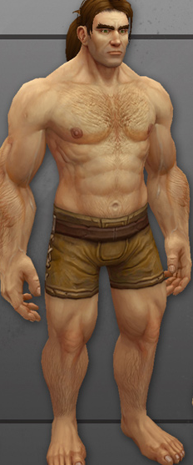

Figure 1

Characteristic: It’s similar to the human beings of earth.

Skin Colors:

 Yellow (255,125,64)

 White (240,183,155)

 Brown (210,105,30)

 Black (73,36,11)

Underclothing[1]:

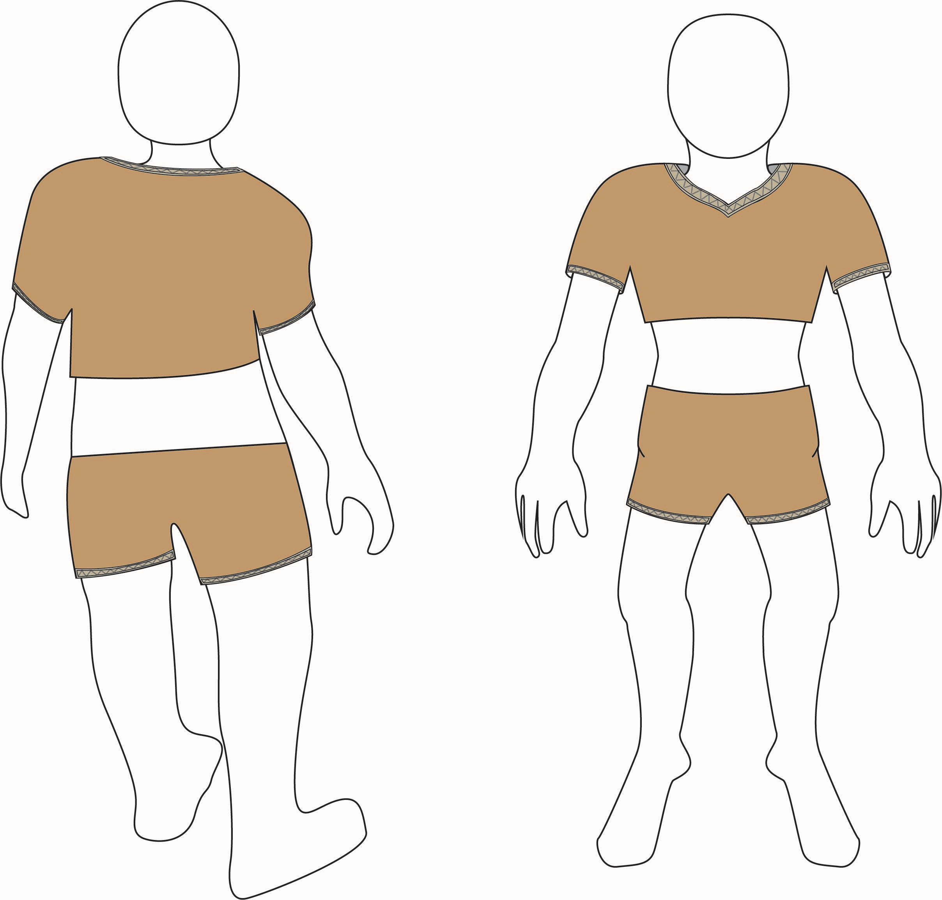

**Oni**:

* Backstory:

Oni is one of the most ancient races in the galaxy. They are born with red skin and two horns on their heads. Most of them live in the mountains in the east area of the world.

* Oni’s customized option:

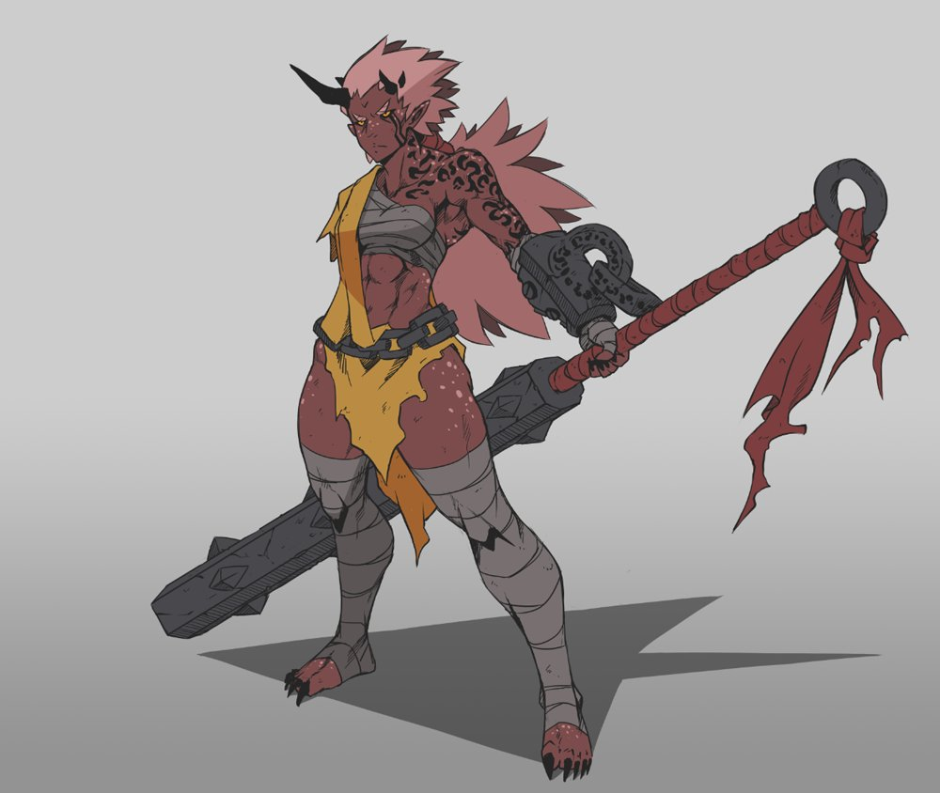

Figure 2

Characteristic: Horns, red skin.

Skin:

 Dark Red (RGB:159,34,9)

 Rose (RGB:255,0,127)

 Violet (RGB:238,130,238)

 Purple (RGB:128,0,128)

Underclothing:

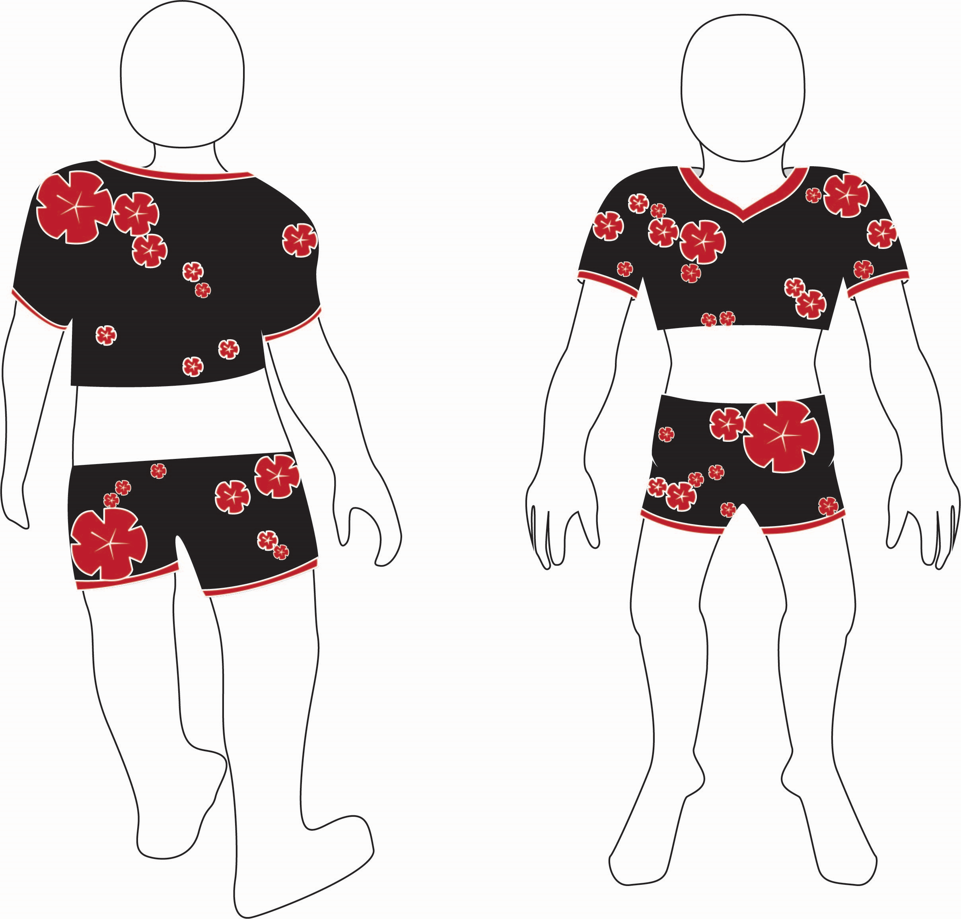

**Outsider**:

* Backstory:

Outsiders came to the Otherworld through the Colonist War. Although they failed the Colonist War, they were then attracted by the ultimate power of the Title of the King. Thus they chose to stay in the Otherworld. The outer space technology they brought greatly pushed the development of Otherworld.

* Outsider’s customized option:

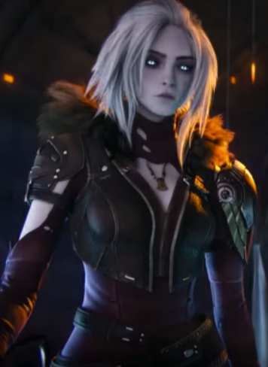

Figure 3

Characteristic: Shining eyes, paleness/blue skin

Skin:

 Paleness (RGB:237,232,226)

 Mint (RGB: 20,236,118)

 Cyan (RGB: 0, 255, 255)

 Dark Blue (RGB: 15:149:185)

Underclothing:

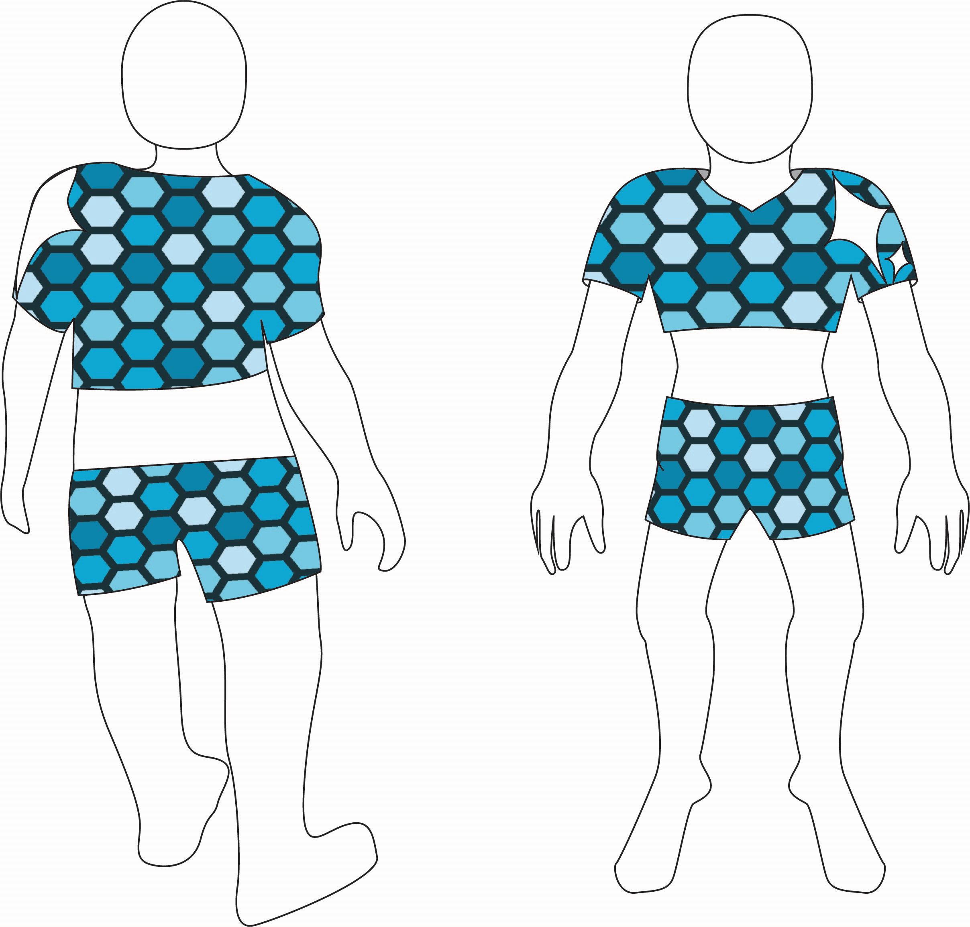

### 2.1.2 Customization Options[2]

Brows:

Eyes:



Eye colors:



Hairs:

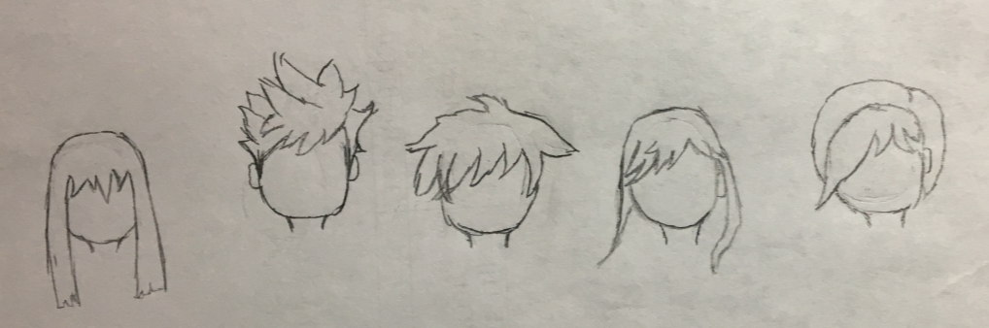

Hair colors:



Noses: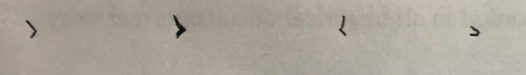

Mouthes:

## 2.2 Non-player Character

### 2.2.1 The Host of the Kingfest

* Backstory:

He is the spokesperson of the Congress. During the Kingfest, only one man of the Congress will show up and hold the event. He always wears a cat-like mask and a black cloak. Till now, no one knows who he truly is.

* Effect in the game:

1. He is the mentor of the players.
2. He teaches them the basic movements and rules of the game.
3. He is one of the key characters.

* Look:

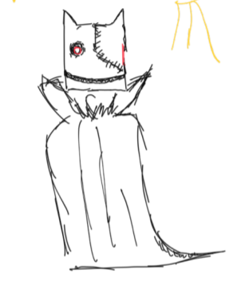

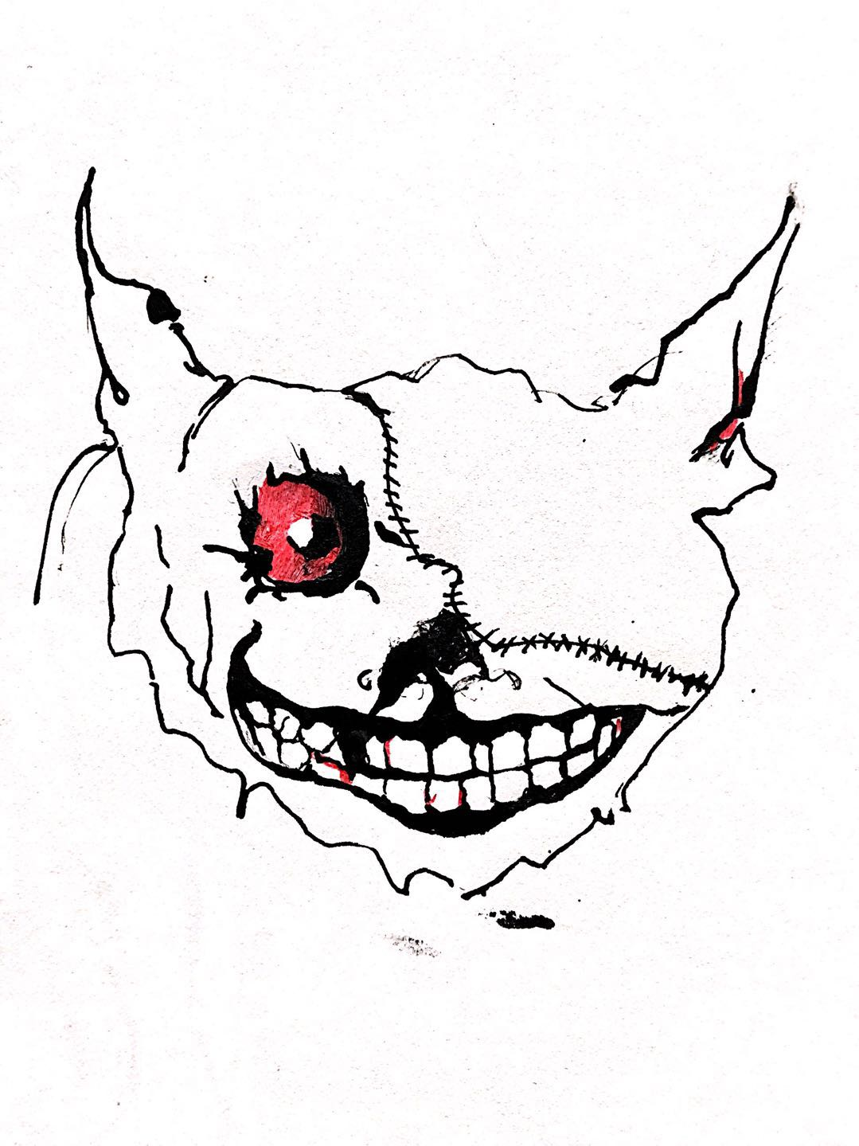

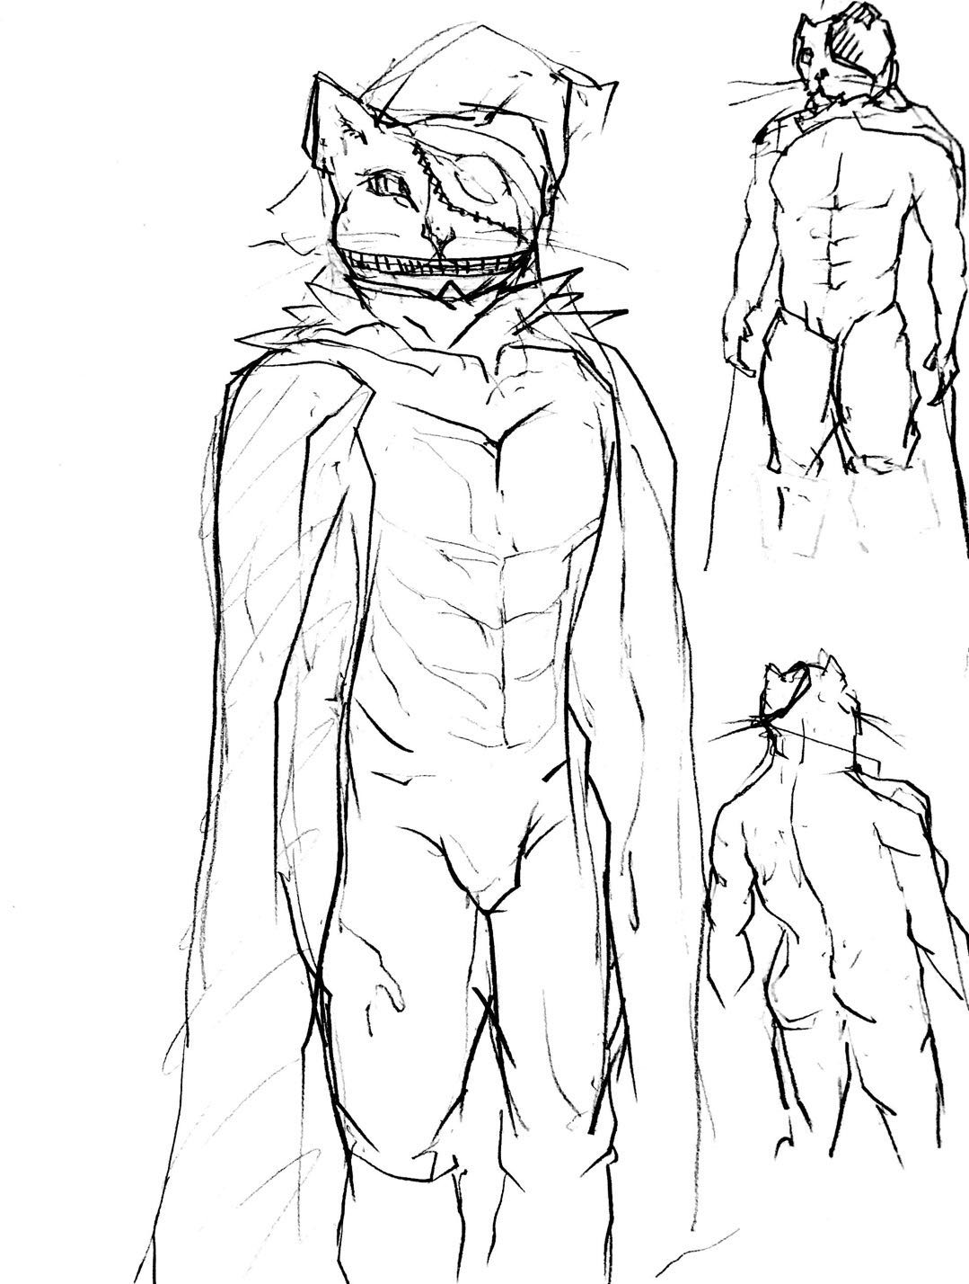

### 2.2.2 Main Characters In the Colonist War:

**The legendary champion:** Arclight of knights - Nazu

* Backstory:

Nazu was born in a poor family, but with his talent, even grown-ups could not fight equally with him when he was only 12 years old. However, because of the lack of education and experience, Nazu spent days and nights fighting and robbing.

One day, however, when Nazu was 15 years old, he met a young man wearing fancy clothes. Nazu drew his knife and sprinted to get close to the young man. Instead of astonishing, the young man smiled, and drew his sword. For the first time, Nazu lost, without any chance or power to beat back. Surprisingly, the young man did not execute Nazu with his beautiful sword, which is “legal” when a nobility does this to a rabble. He was impressed by the power and confidence of this wolf-like boy.

“Wanna go with me?”

Nazu was waiting for the execution. However, what he saw was not the sword, but a extending hand. At the same time, a bunch of light penetrated the clouds and lighted the bodies of the two young men. This must be fate, Nazu thought, extending his hand.

The young man was the prince of the country, and he would become the king in the future. Since that day, studying and training together became Nazu and the prince’s daily life. About one year later, Nazu learned all the skills for combatting and the prince could no longer fight against Nazu any more. And Nazu became much more optimistic and educated. This happy life lasted for five years.

One day, while training, Nazu discovered that the prince was acting weird. It was apparent that the prince was a little bit sad and could not focus on the training. Nazu acquired for the reason. The prince did not want to tell Nazu at first, but he gave the reason at last.

It was the time for a new competition to determine the next hero to inherit the title of the king. Eight warriors would fight at a place for glory and power. This year, however, there was not enough volunteers. The reason is that, the warriors would fight each other until only one person is alive. In another word, the participants would either die or obtain the title of the king. However, in both way, the participants would not return to their home any more. Since there were not enough volunteers this year, the prince should become one of them, and then he would not return or inherit the king of the country.

Hearing that, Nazu made his decision without hesitation. He stabbed his sword into the ground, kneeled on one knee, “I will become the last volunteer.”

“No...no no no. I won’t allow you to sacrifice yourself to…”

“You changed my life, my lord. I would have become a murderer and sent into prison if I did not met you on that day. I will swear my sword to protect you and fight for the glory and power, prince.” The prince at first did not agree with Nazu, but gave up and let Nazu become the last warrior at last.

The day arrived. Nazu went aboard and left without turning back even once.

Two days later, they arrived at the place, where was a beautiful place but filled with the smell of blood. All the participants were skilled. Some of them used magic while the others had extremely strong bodies. They were from different countries, of different races, but had the same purpose -- to survive until the end and to inherit the “Title of the King”. Fought with the magic horse given by the prince and his legendary gun (which was titled legendary after the competition) , Nazu defeated all the rest seven heros. The last battle was between the Revenger-Aoji and Nazu. They fought for a whole day, and finally Nazu pierced his edge into this prince in the past who was revived by hate and despair.

“I will die, but the revenge never stops...” saying his last words, Aoji’s body scattered and disappeared into dusts.

Nazu became the champion and obtained the title of the king.

The moment after Nazu was given the powerful media -- the Title of the king, hundreds of floating ships appeared in the sky. The invade by the outsiders started. They owned surpass technology and wanted to occupied Otherworld by force.

“Let’s try this.” Nazu said.

What happened since the next second is recorded in all historical documents and story books written after.

Fusing the Title of the king and his own gun, Nazu created this most powerful weapon in the universe -- star devastator.

Smiling, Nazu pressed the trigger.

A bunch of light sliced the enemies’ armada, and left the sky with the brightness that lasted for months.

“What should we call it? It doesn’t matter! No one wants to trigger that again, even those who want to obtain the ultimate power. It just makes everything gone, nothing left, nothing!” said the greatest weapon master in the history.

**Other seven heroes:**

Human:

The revenger -- Aoji: He was a prince in the past, but was assassinated by his enemy. He was revived to revenge for himself. However, he fell into darkness and killing became his own aim. He was good at arrow and sword. His own weapons were able to absorb others’ life force.

The earth-shaker -- Weikon: Weikon’s race was famous for power and their strong bodies. Weikon was born just like his clansmen, or even more powerful. He is good at handling heavy weapons like hammer and axe. In the legend, he was able to shake the ground with his legendary hammer.

The element terminator -- Mistily: Before the battle, Mistily was widely known as a witch who could control all the elements and create miracles. Her staff was told to be alive and could not be used by others who are not acknowledged by it.

The library of human’s intelligence -- Biotheca: Biotheca knew all the knowledge about the world except for the secret of the title of the king. She was not good at battling. but was able to use her knowledge and intelligence to defeat monsters. She also died of her kindness, and was killed by Aoji.

Oni:

The terror of the darkness -- Akuma: Born from the fear and despair of human lived in the east, Akuma “lived” from the negative feelings of human. It could create fear of people from nothing, and absorb their life force. It could also become invisible and kill people from behind, with his sickle.

The blade of blood moon -- Akaya: No one knew what she or he looked like, except for Nazu, because nobody else kept alive after seeing it. There was a rumor that Akaya was a short girl with short hair and small horns. She had red eyes, with the same color as the blood moon, a myth in the east. No one knows if it is true. However, Akaya’s weapon is well-known. It was said to be the lightest and fiercest knife in the world.

The cold memory -- Yuki: No one remembered her. A common communication among parents and children is “Mom, do you know who the eight warriors of the legendary battle were?” “Well… I can only come up with seven now, babe.” Those who still remember her, however, treat her as one of the largest threat and fear. “She can easily appear behind you and turn you into ice. Even if you stay alive fortunately, you will forget what happened to you.” Actually, someone thinks she is still alive even today.

# 3. Player Details And Monsters’ Attack Styles

## 3.1 Player

**Health Points (HP):**

HP is an attribute that determines whether the player is alive or not. Every player has 100 HP initially. During the game, if the player is attacked by different kinds of weapons, his/her HP will be reduced or increased in range from 0 HP to 200 HP. Once the player’s HP is lower or equal to 0, the player will kneel on the ground and will enter the stage of “near death.” In the near death stage, the player cannot do anything but wait for his/her teammates to pull him/her up. After “near death” for 5 seconds, the player is dead. Once a player is dead, others are no longer able to save him/her. In the Safari (Player Versus Player) mode, one teammate’s death will make all players in the team die.

The player can be healed either by using items or by using abilities. The maximum HP a player can reach is 200 HP.

**Moving Speed:**

Moving speed is an attribute that determines how fast a player can move. Its initial value is 10 Speed Unit (su) with 10 su up or down. The player can get different types of shoes during the game. Each pair of shoes has different kinds of bonuses for the player’s speed. Shoes can be either an add-on constant of moving speed (5, 10 etc.) or percentage (10%, 20% etc.)

**Armor:**

Armor is a different attribute than HP that gives the player extra protection that ranges from 0 - 100. The armor status bar is shown underneath the HP bar.

There are different kinds of Armors in the game that offer various additions on HP. When a player is shot, it’s possible that he loses his HP instead of Armor.

## 3.2 Enemies

### 3.2.1 Boss[3]

|  |  |  |  |
| --- | --- | --- | --- |
| **Attack Style** | Shooting | **Attack Damage** | 110 |
| **Moving Speed** | Not moving | | |
| **Characteristic** | In this attack style, the boss aims at all the players at the same time. Before it shoots, players will be alarmed so they can find places to hide themselves. The alarm will become more frequent before it attacks. The time period between each shot is always the same, so that players can make strategies and attack the boss. | | |

|  |  |  |  |
| --- | --- | --- | --- |
| **Attack Style** | AOE[4] and Close Combat | **Attack Damage** | 50 |
| **Moving Speed** | 15 | | |
| **Characteristic** | The boss is invisible when it doesn’t attack, but players nearby can hear the sound of chains rubbing the ground before it appears. It has two stages based on its remaining health. For the first stage, it appears less frequently, but for the second stage, it appears more frequently and after each attack, it will leave fire on the ground, dealing damage to those who stand on the fire. | | |

|  |  |  |  |
| --- | --- | --- | --- |
| **Attack Style** | AOE and Rapping | **Attack Damage** | 70 |
| **Moving Speed** | 7 | | |
| **Characteristic** | If players stand inside the attack range, they are too afraid to move. The boss’s attack will lead to a short time where the player cannot move. | | |

### 3.2.2 Monster

|  |  |
| --- | --- |
| **Attack Style** | Close Attack |
| **Attack Damage** | 10 |
| **Health** | 20 |
| **Moving Speed** | 15 |

|  |  |
| --- | --- |
| **Attack Style** | Self-explosion AOE (Can also damage monsters nearby) |
| **Attack Damage** | 0-100 |
| **How To Trigger** | Explode after a short delay or explode after being touched |
| **Moving speed** | 12 |

|  |  |
| --- | --- |
| **Attack Style** | Shoot from a shield covered in a fixed direction(The shield can be damaged) |
| **Attack Damage** | 5 |
| **Moving Speed** | The monsters can’t move while shield is up |
| **Shield Put Away Speed** | 8 |

|  |  |
| --- | --- |
| **Attack Style** | Rifle |
| **Attack Damage** | 20 |
| **Health** | 30 |
| **Moving Speed** | 10 |
| **Things To Note** | The monster is human-looking. It can hide under bunker. Its shooting accuracy is very low. |

|  |  |
| --- | --- |
| **Attack Style** | Sniper Rifle |
| **Attack Damage** | 80 |
| **Health** | 30 |
| **Things To Note** | There are about 2-3 of these kind of monsters total. It’s human-looking. It always hides behind bunker so it doesn’t move. |

# 4. Enemies AI

|  |  |
| --- | --- |
| BOSS | |
| 1 | It aims at everyone who is alive. |
| 2 | It randomly chooses its target and teleports behind its target. |
| 3 | It gets close to a random player before attacking. |
| 4 | It faces its target when it’s attacking. |
| Monsters | |
| 1 | It gets close to a random player before attacking. It will face its target when attacking. It cannot move while attacking. |
| 2 | It follows a random player until it explodes. |
| 3 | After this monster is damaged, it will set a shield facing the direction the damage is from and shoot players one by one from behind the shield. When it cannot see any more players, it will pick up the shield and move. It cannot move when the shield is set. |
| 4 | This monster cannot attack while moving. After it appears, it will move to find the nearest bunker, hide behind it and shoot random players it can see. |

# 5. Character Animation List

## 5.1 Basic Animation

In this section, we planed to learn the existing and time-tested animation designs from other top-down shooter games, such as “Helldivers.” We took short video clips[5] of each similar animation in “Helldivers” and counted the frame of those animations by using Adobe Premiere.

In Adobe Premiere, first, we reset the place of the playhead at the beginning of the animation and marked the start time. In this case, the unit of time is a frame. Then, we moved the playhead through this animation till its end. We marked the end time and then subtracted the start time. In this way, we calculated the frame of each animation. [6]

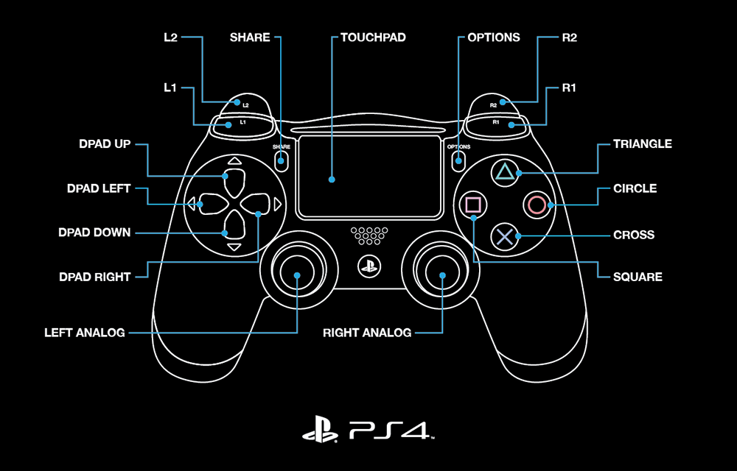

Figure 4 [7]

|  |  |
| --- | --- |
| **Stand** | |
| **Key** | No Key Is Pressed |
| **Note** | N/A |
| **Frame** | N/A |

|  |  |
| --- | --- |
| **Sprint** | |
| **Key** | Hard Push Left Joystick |
| **Note** | Both joysticks of the PS4 controller are 10-bit precision. This means the joystick has 1024 possible input values (from 0 - 1024). From scale degree 0% to 100% (0 - 1024), **hard push** is 31% - 100%. |
|
| **Frame** | 25 |

|  |  |
| --- | --- |
| **Walk** | |
| **Key** | Light Push Left Joystick |
| **Note** | Both joysticks of the PS4 controller are 10-bit precision. This means the joystick has 1024 possible input values (from 0 - 1024). From scale degree 0% to 100% (0 - 1024), **light push** is 0% - 30%. |
|
| **Frame** | 15 |

|  |  |
| --- | --- |
| **Lie Down** | |
| **Key** | Square Button |
| **Note** | Due to the inertia on the planet, the player who performs “lie down” will slide on the ground for a short distance. |
| **Frame** | 44 |

|  |  |
| --- | --- |
| **Across the Barrier** | |
| **Key** | Cross Button |
| **Note** | N/A |
| **Frame** | 40 |

|  |  |
| --- | --- |
| **Turn** | |
| **Key** | Light Push Right Joystick |
| **Note** | 1. Both joysticks of the PS4 controller support 360° rotation angle. If the player pushes the right joystick to a direction, the hero will turn to the same direction.  2. Just like Sprint and Walk, if the player applies a **light push** to the right joystick, the hero will “Turn.” |
|
| **Frame** | 0 frame (immediate action) |

|  |  |
| --- | --- |
| **Aim** | |
| **Key** | Hard Push Right Joystick |
| **Note** | 1. Both joysticks of the PS4 controller support 360° rotation angle. If the player pushes the right joystick to a direction, the hero will turn to the same direction.  2. Just like Sprint and Walk, if the player applies a **hard push** to the right joystick, the hero will “Turn then Aim.” |
|
| **Frame** | 5 |

|  |  |
| --- | --- |
| **Melee** | |
| **Key** | Circle Button |
| **Note** | N/A |
| **Frame** | 20 |

|  |  |
| --- | --- |
| **Reload** | |
| **Key** | R3 Button |
| **Note** | If the player presses the R3 button in a **perfect timing**, the player will be able to reload **very quickly**. If the player **misses the perfect timing**, the player will reload **fairly slowly**. |
| **Frame** | 38 |

|  |  |
| --- | --- |
| **Pull Up the Agonal Teammate** | |
| **Key** | No Key Required |
| **Note** | It costs 3 seconds for a player pulling up his teammate. |
| **Frame** | 3 seconds (90 frames) |

|  |  |
| --- | --- |
| **Shoot** | |
| **Key** | R2 |
| **Note** | N/A |
| **Frame** | 0 (if the player is aiming) |

|  |  |
| --- | --- |
| **Dance** | |
| **Key** | Down Button |
| **Note** | N/A |
| **Frame** | 3 seconds (90 frames) |

## 5.2 Animation Integration Plan

We list all important and possible combinations of animations that a player can perform in the game.

1. Stand → Walk
2. Stand / Walk → Aim
3. Stand / Walk → Sprint
4. Stand / Walk / Sprint → Lie Down
5. Stand / Walk / Sprint → Across the Barrier
6. Stand / Walk / Sprint → Melee[8]
7. Stand / Walk / Sprint → Turn
8. Stand / Walk / Sprint → Shoot
9. Stand / Walk / Sprint → Reload
10. Stand → Pull Up the Teammate
11. Stand → Dance
12. Aim → Shoot

# Image Reference

Figure 1: From *World of Warcraft*

Figure 2: <https://twitter.com/hushabye_valley/status/829121280079192066>

Figure 3: From *Destiny*

Figure 4: From Playstation Official Site

1. When a player enters a match, he/she will only wear the underclothing, since he/she needs to collect armor in the arena. Different race has different style of underclothing.
2. These options are open for all races.
3. Some bosses may have several attack styles, yet some may only have one style.
4. AOE, area of effect, is a term used in gaming to describe area attacks.
5. The original video clips are shooted in 30 frames per second.
6. The error of this method is +-2 frames.
7. Analog = Joystick
8. If a player perform Melee when he/she Sprints, after the Melee, he/she will Walk.